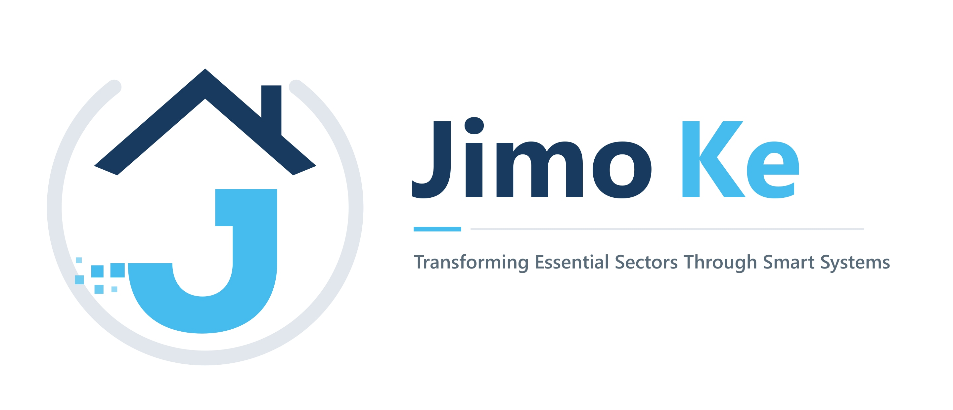

Company Profile
Transforming Essential Sectors Through Smart Systems
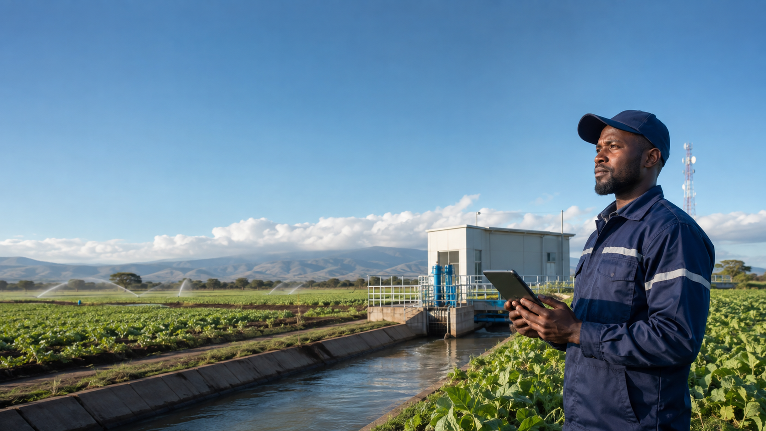
Germany and Kenya support footprint

Company Overview
Jimo Ke brings digital systems and practical field operations together across agriculture, water and sanitation, enterprise systems, and farm support. The company is structured to support essential sectors with tools that improve visibility, coordination, and day-to-day control.
Vision To become a trusted international group that uses smart systems to improve essential services and productive sectors.
Mission To design and support practical digital and operational solutions that help farms, utilities, institutions, and businesses work with greater visibility, consistency, and control.

Company Focus
- Digital systems that support real operational work.
- Agriculture technology and direct farm operations support.
- Water and sanitation information, asset, and field workflows.
- ERP and business systems suited to each organisation's processes.
- Ongoing implementation support through Kenya and Germany contact points.

Who We Serve
Jimo Ke is positioned to work with farms, agribusinesses, water service organisations, public institutions, growing companies, and development partners that need practical systems and dependable implementation support.

Service Portfolio
The portfolio combines software, operational support, and sector knowledge. Engagements can begin with one focused workflow and expand as priorities become clearer.
Service Area | Typical Work | Primary Context
Digital Transformation | Process mapping, data capture, dashboards, mobile workflows, and system integration | Operations that need clearer information and simpler coordination
Agriculture Technology | Farm records, crop planning, input tracking, irrigation monitoring, and field reporting | Farms, producer groups, and agribusiness operations
Water and Sanitation | Asset registers, service requests, field inspections, maintenance planning, and operational reporting | Utilities, schemes, institutions, and community systems
ERP and Business Systems | Finance, procurement, inventory, human resources, sales, and approval workflows | Organisations replacing disconnected spreadsheets or manual processes
Farm Operations | Production planning, activity coordination, labour records, harvest tracking, and management reporting | Jimo Ke farm activities and supported farm operations

Agriculture and Farm Operations
Jimo Ke connects farm management with practical digital records so decisions reflect field activity, input use, labour, crop condition, and production progress.
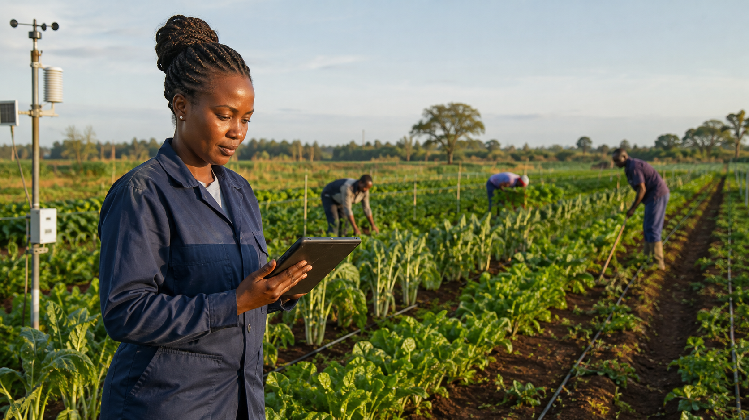

Areas of Support
- Farm and field record systems designed around actual production routines.
- Crop planning, input use, labour activity, and harvest tracking.
- Irrigation records and integration of sensor or weather information where appropriate.
- Operational reporting for managers, owners, and implementation partners.
- Support for Jimo Ke farm operations and selected partner farms.

Water and Sanitation
Water and sanitation operations depend on reliable asset information, responsive field work, and consistent reporting. Jimo Ke focuses on digital workflows that strengthen those everyday responsibilities.
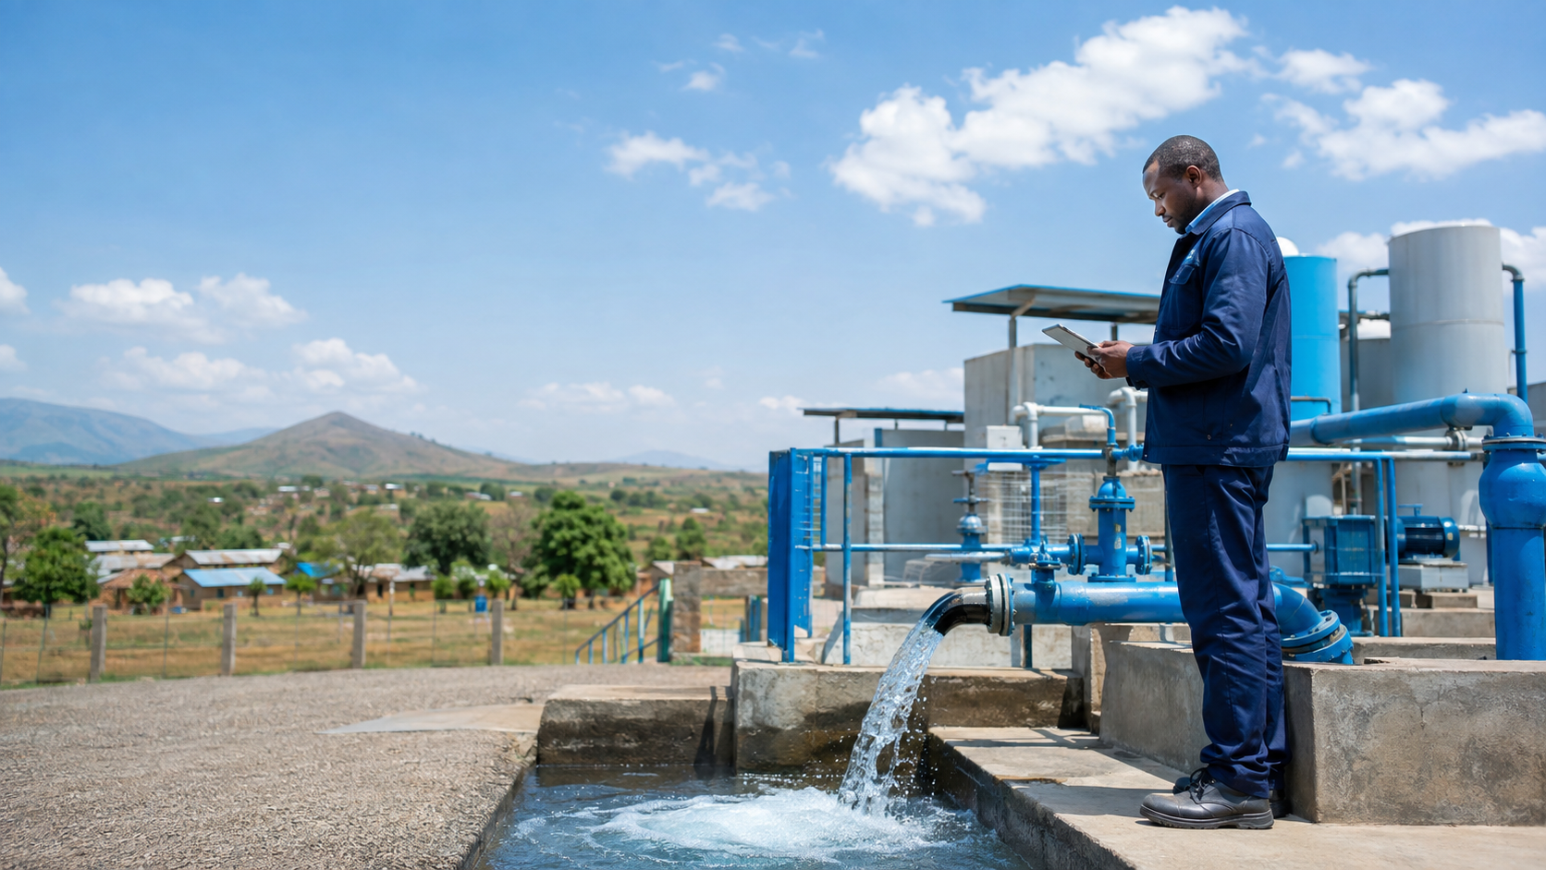

Areas of Support
- Asset registers for treatment, pumping, storage, and distribution infrastructure.
- Mobile field inspection, maintenance, and service request workflows.
- Operational records for water quality, plant activity, and sanitation services.
- Management dashboards and routine reports based on captured field data.
- Integration with finance, inventory, procurement, or customer systems where required.

Digital Systems and ERP
Jimo Ke approaches ERP and digitalisation as operational change. The work begins with how people perform tasks, make approvals, record transactions, and use information across departments.


Typical Capabilities
- Business process assessment and practical requirements definition.
- ERP modules for finance, procurement, inventory, people, sales, and operations.
- Dashboards, management reports, and structured data capture.
- Integration between field tools, core business systems, and reporting workflows.
- User support, documentation, and phased improvement after implementation.

Delivery and Support Model
Each engagement should have a clear operational purpose, a manageable first scope, and an agreed support path. This helps teams adopt useful systems without creating unnecessary complexity.
Stage | Phase | Purpose
1 | Understand | Clarify the work, users, information needs, and constraints.
2 | Design | Define the workflow, solution scope, responsibilities, and rollout plan.
3 | Implement | Configure or build the solution, prepare users, and introduce it in practical stages.
4 | Support | Resolve issues, improve reporting, and extend the system when priorities justify it.

Two Office Support Footprint
Germany Office Provides an EU contact point and support coordination for Germany and European engagements.
Nairobi and Farm Support Provides Kenya-based agriculture support and a practical contact point for local operations.

Contact Jimo Ke
Contact the office closest to your work, or use the general email address for company enquiries and partnership discussions.


Germany
Germany Office
+49 162 7104977
WhatsApp +49 162 7104977
info@jimoke.com
Germany, EU support office

Kenya
Nairobi / Farm Support
+254 724401092
WhatsApp +254 724401092
kenya@jimoke.com
Kenya agriculture support desk

